**240840520043_Paresh_Joshi**

Section A

1.

create table flats(

flatid int primary key auto_increment,

flatnumber varchar(10),

block varchar(10)

);

create table residents(

residentid int primary key auto_increment,

fullname varchar(100),

flatid int,

foreign key(flatid) references flats(flatid) --Defined foreign key relationship here

);

create table maintenance(

maintenanceid int primary key auto_increment,

flatid int,

ammount decimal(8,2),

foreign key(flatid) references flats(flatid) --Defined foreign key relationship here

);

insert into flats(flatnumber, block) values

('f001', 'A'),

('f002', 'B'),

('f003', 'C'),

('f004', 'A'),

('f005', 'B'),

('f006', 'C');

insert into residents (fullname, flatid) values

('Paresh', 1),

('Ritesh', 2),

('Naresh', 3),

('Suresh', 4),

('Ramesh', 5),

('Ganesh', 6),

('Sahara', 6);

insert into maintenance(flatid, ammount) values

(1, 1500.00),

(2, 2500.00),

(3, 1000.00),

(4, 1750.00),

(5, 00.00),

(6, 3500.00);

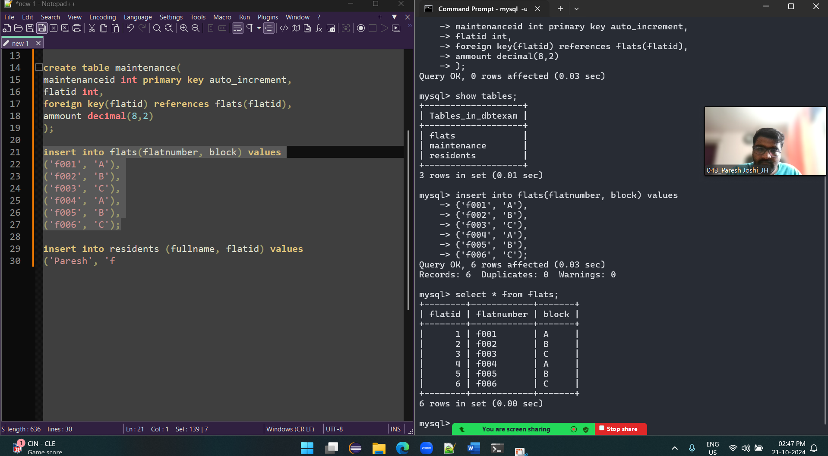

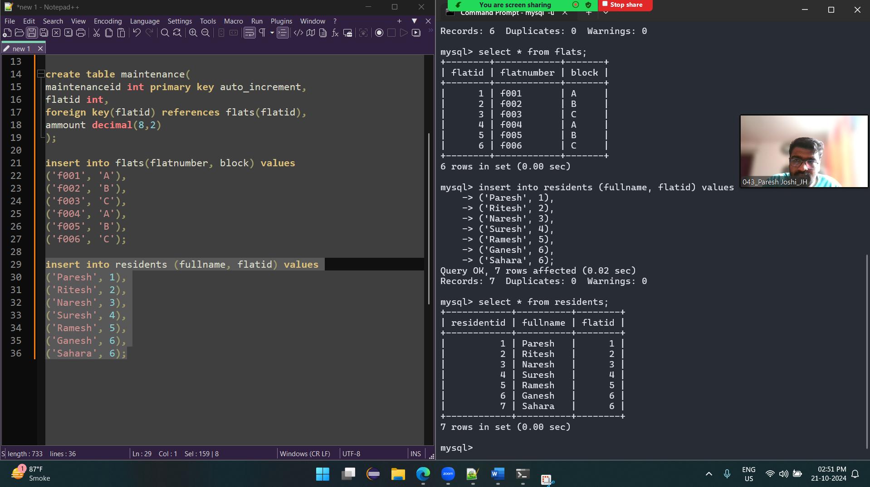

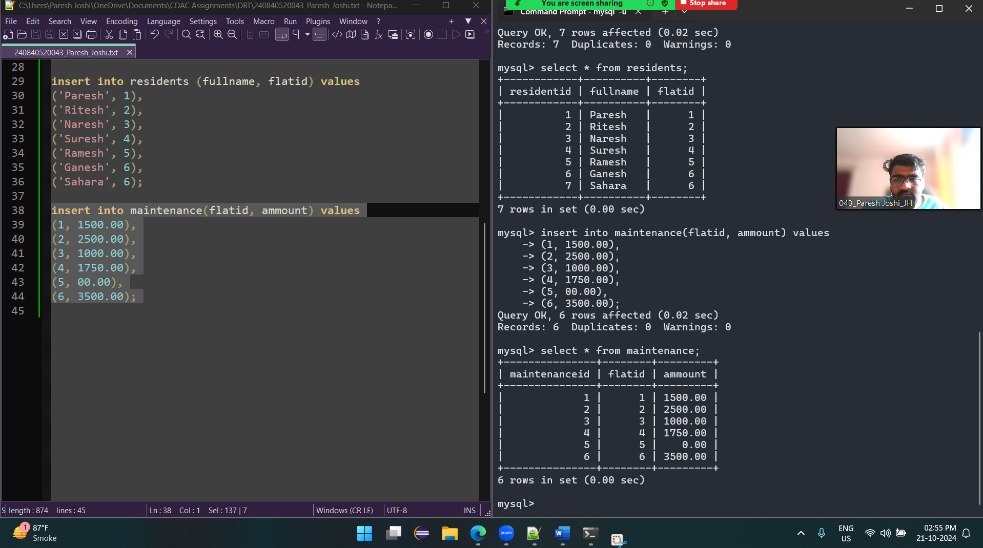

2. FOREIGN KEYS are defined on line 11 & 18

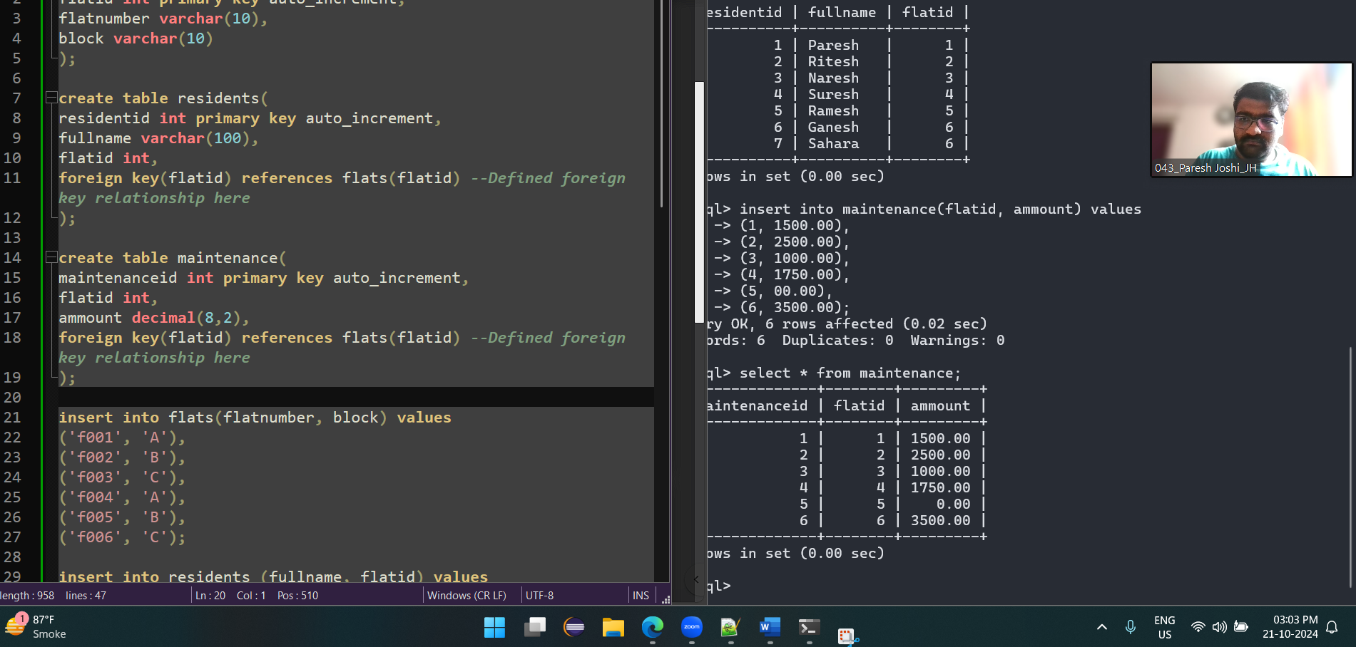

3.

select residents.fullname, flats.block, maintenance.ammount from flats, maintenance, residents

where flats.flatid = residents.flatid and residents.flatid = maintenance.flatid and (flats.block = 'A' or maintenance.ammount > 2000);

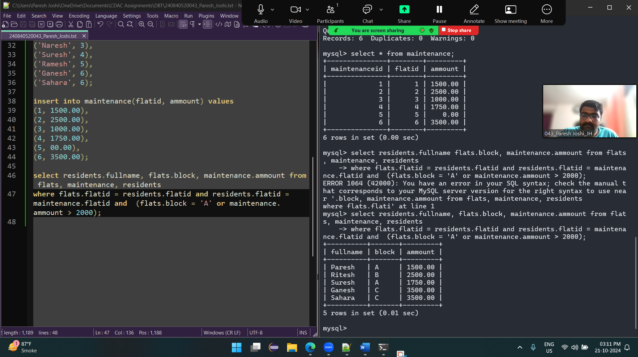

4.

select * from maintenance limit 5;

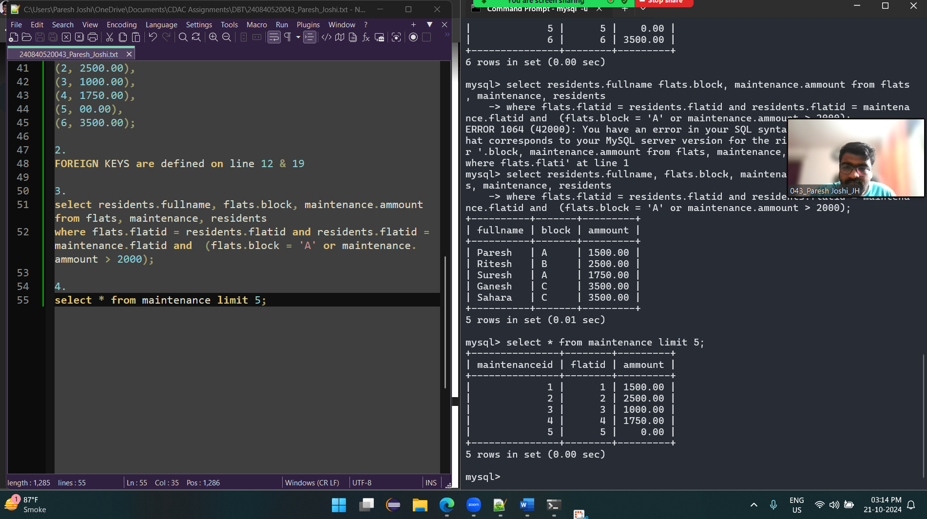

SECTION B

1.

select distinct flats.block, sum(maintenance.ammount) from flats, maintenance

where flats.flatid = maintenance.flatid

group by flats.block;

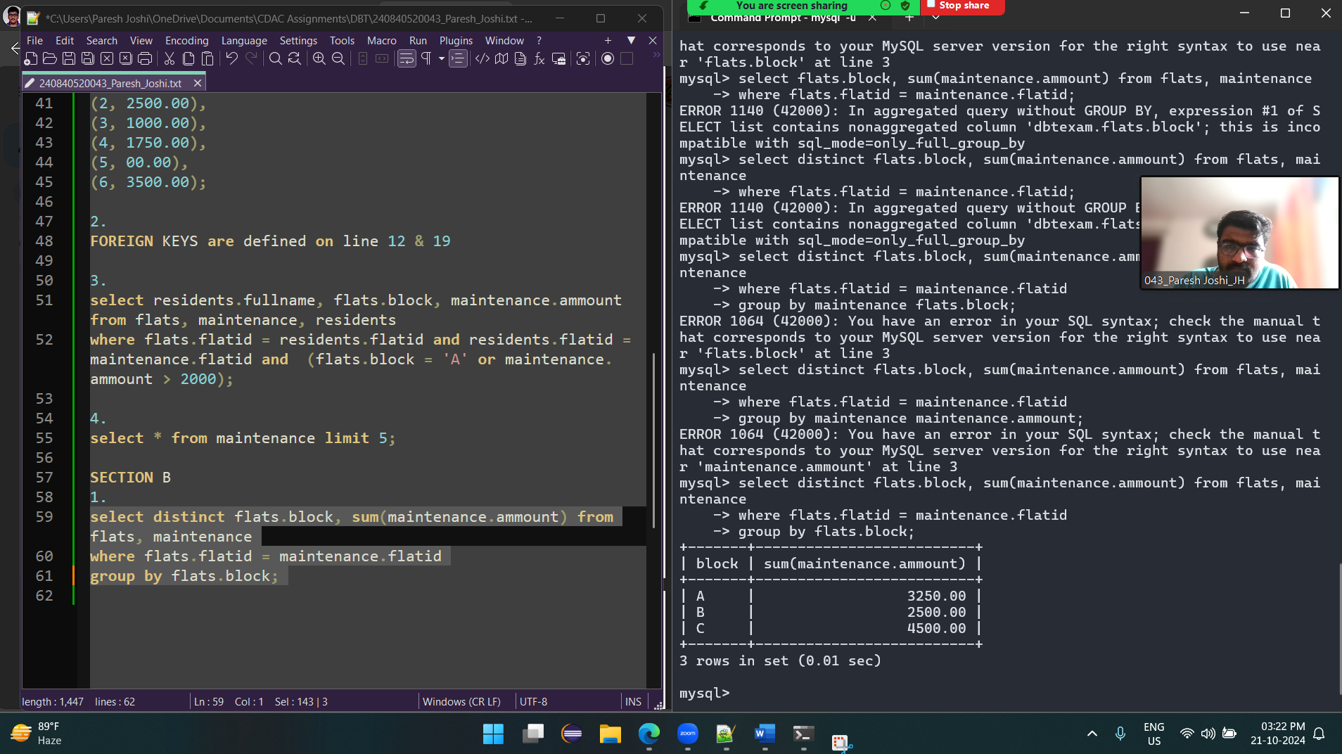

2.

select flats.flatnumber, maintenance.ammount from flats, maintenance

where flats.flatid = maintenance.flatid and

maintenance.ammount = (

select max(ammount) from maintenance);

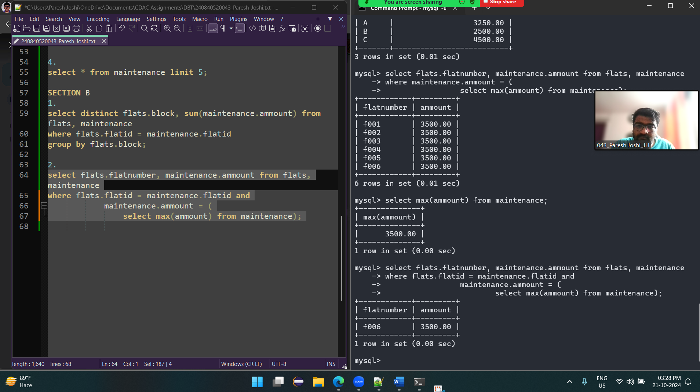

3.

create view maintenancesummary as

select flats.flatnumber, maintenance.ammount from flats, maintenance

where flats.flatid = maintenance.flatid;

update maintenancesummary

set ammount = 2200

where flatnumber = 'f005';

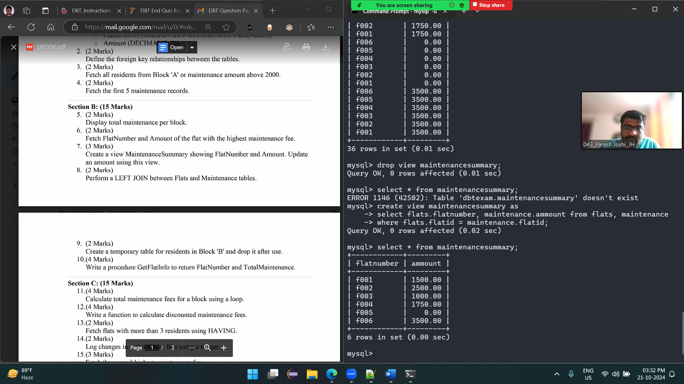

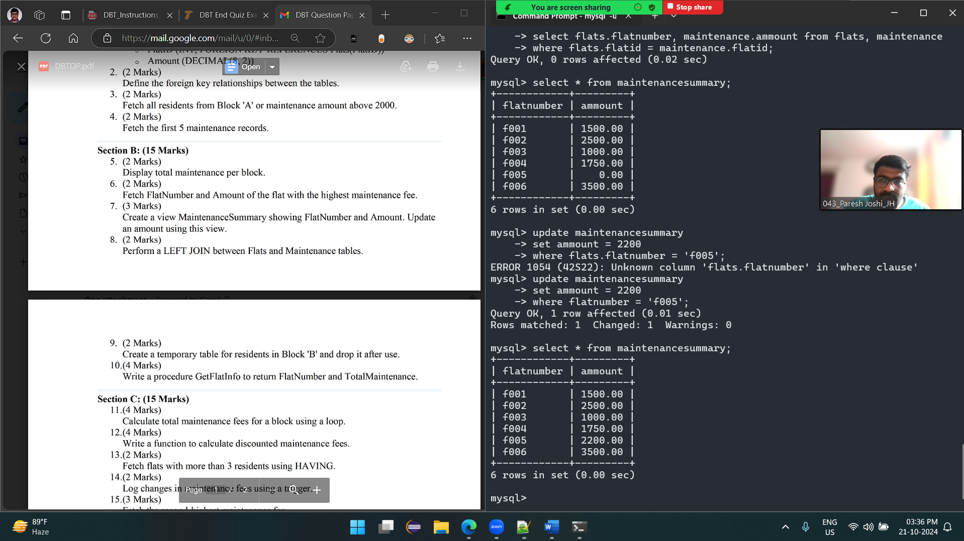

4.

select * from flats, maintenance

where + flats.flatid = maintenance.flatid;

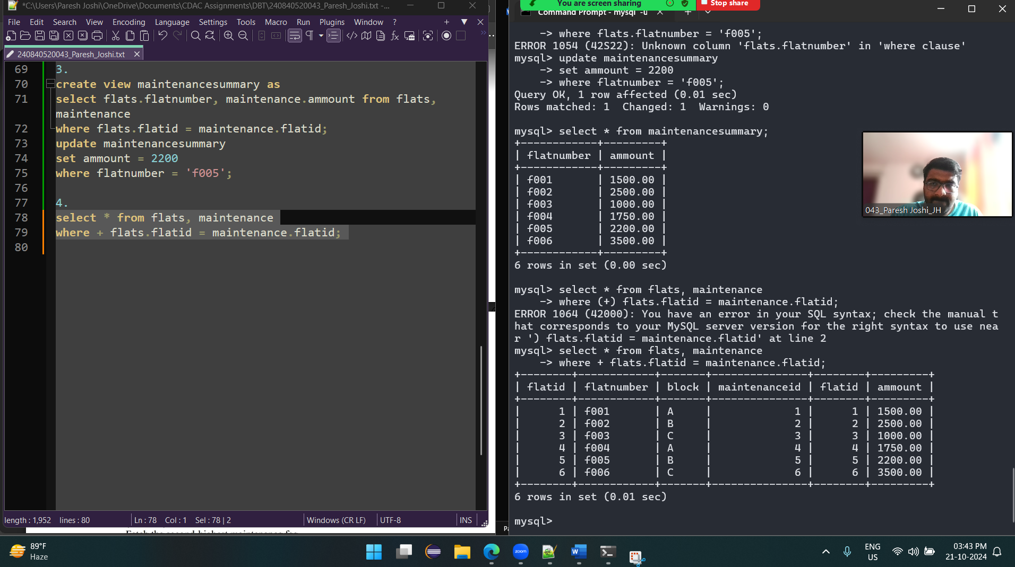

5.

create table tempTable as

select residents.fullname, flats.block from flats, residents

where flats.flatid = residents.flatid and flats.block = 'A';

drop table tempTable;

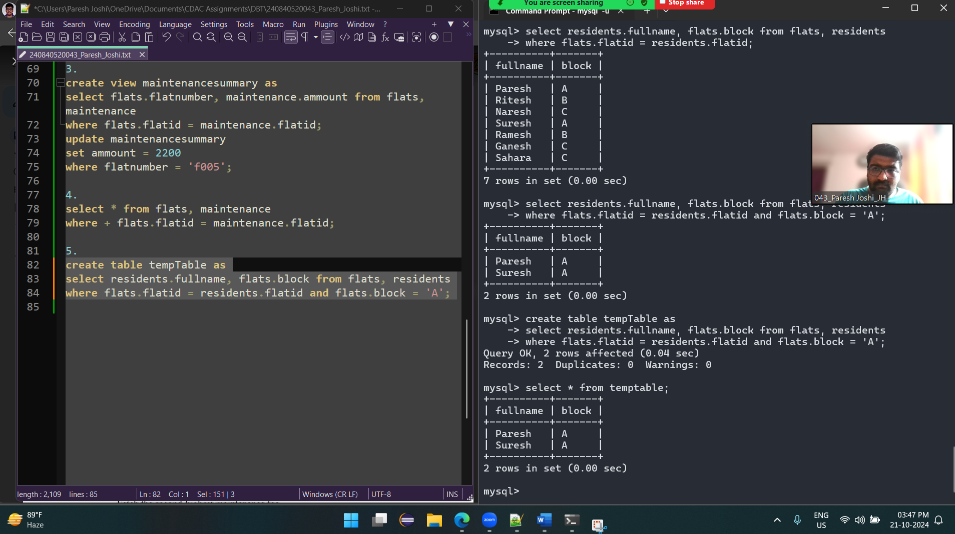

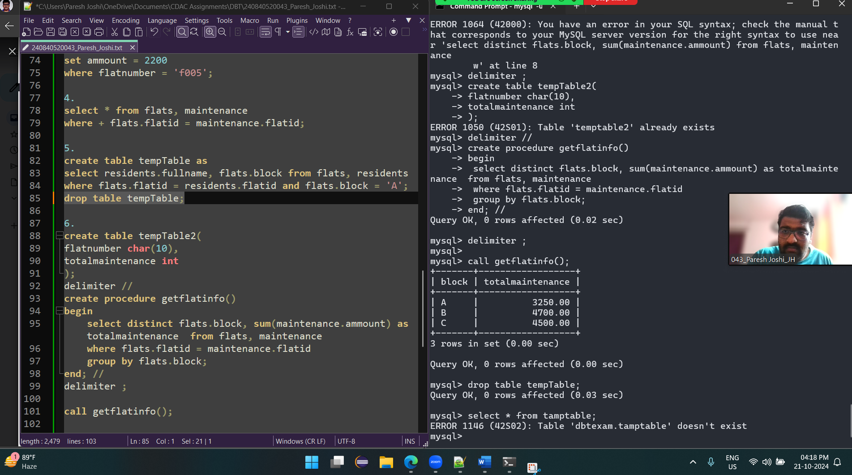

6.

delimiter //

create procedure getflatinfo()

begin

select distinct flats.block, sum(maintenance.ammount) as totalmaintenance from flats, maintenance

where flats.flatid = maintenance.flatid

group by flats.block;

end; //

delimiter ;

call getflatinfo();

